**Sprite Replica Test Procedure**

**Test Tools:**

**Hardware:** TI Launchpad, mini USB Cable, pogo pin programming fixture

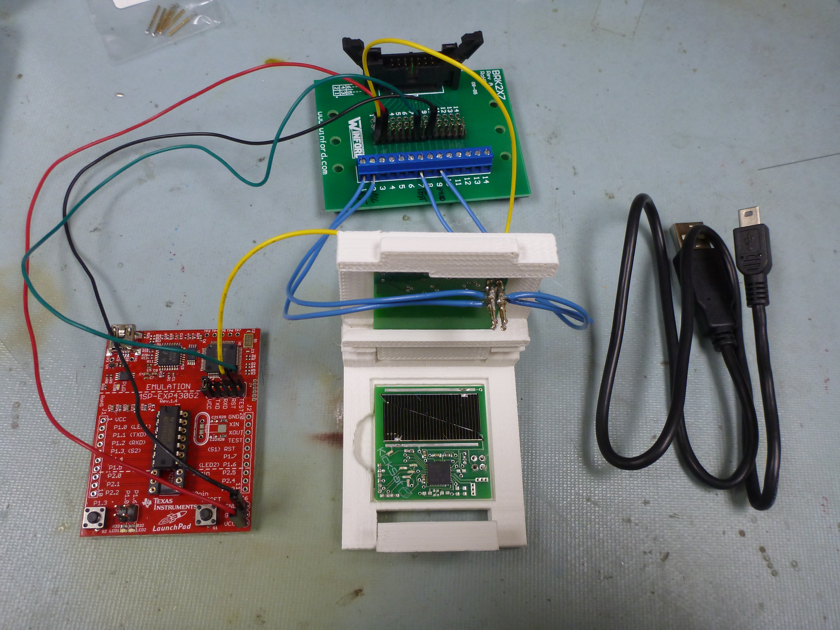

**Software:** Energia customized build available at the following URL: <https://github.com/zacinaction/Energia/downloads>, SpriteBlink demo sketch (included in download).

**Test Procedure:**

1. Connect wires from test fixture to TI Launchpad. These are VCC (red), GND (black), TEST(green), and RST (yellow) and will be marked on both the board and test fixture.
2. Place Sprite board into the programming fixture.

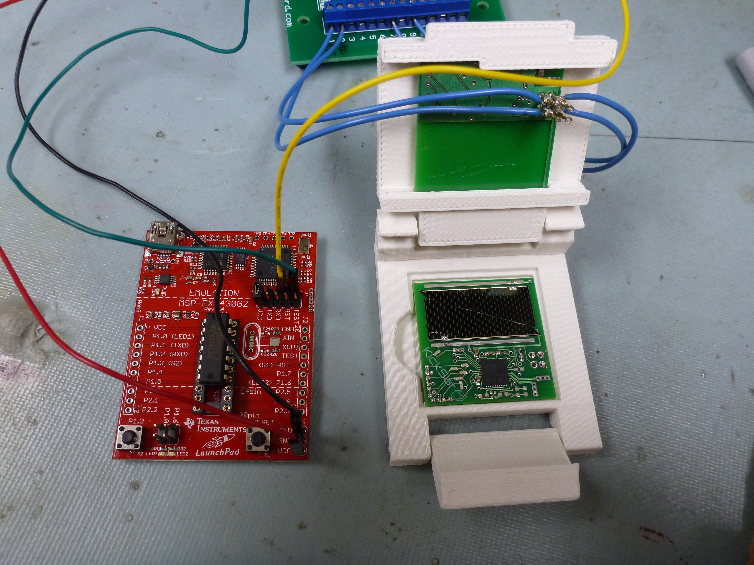

1. Close and latch lid, ensuring that pins make good contact with board.

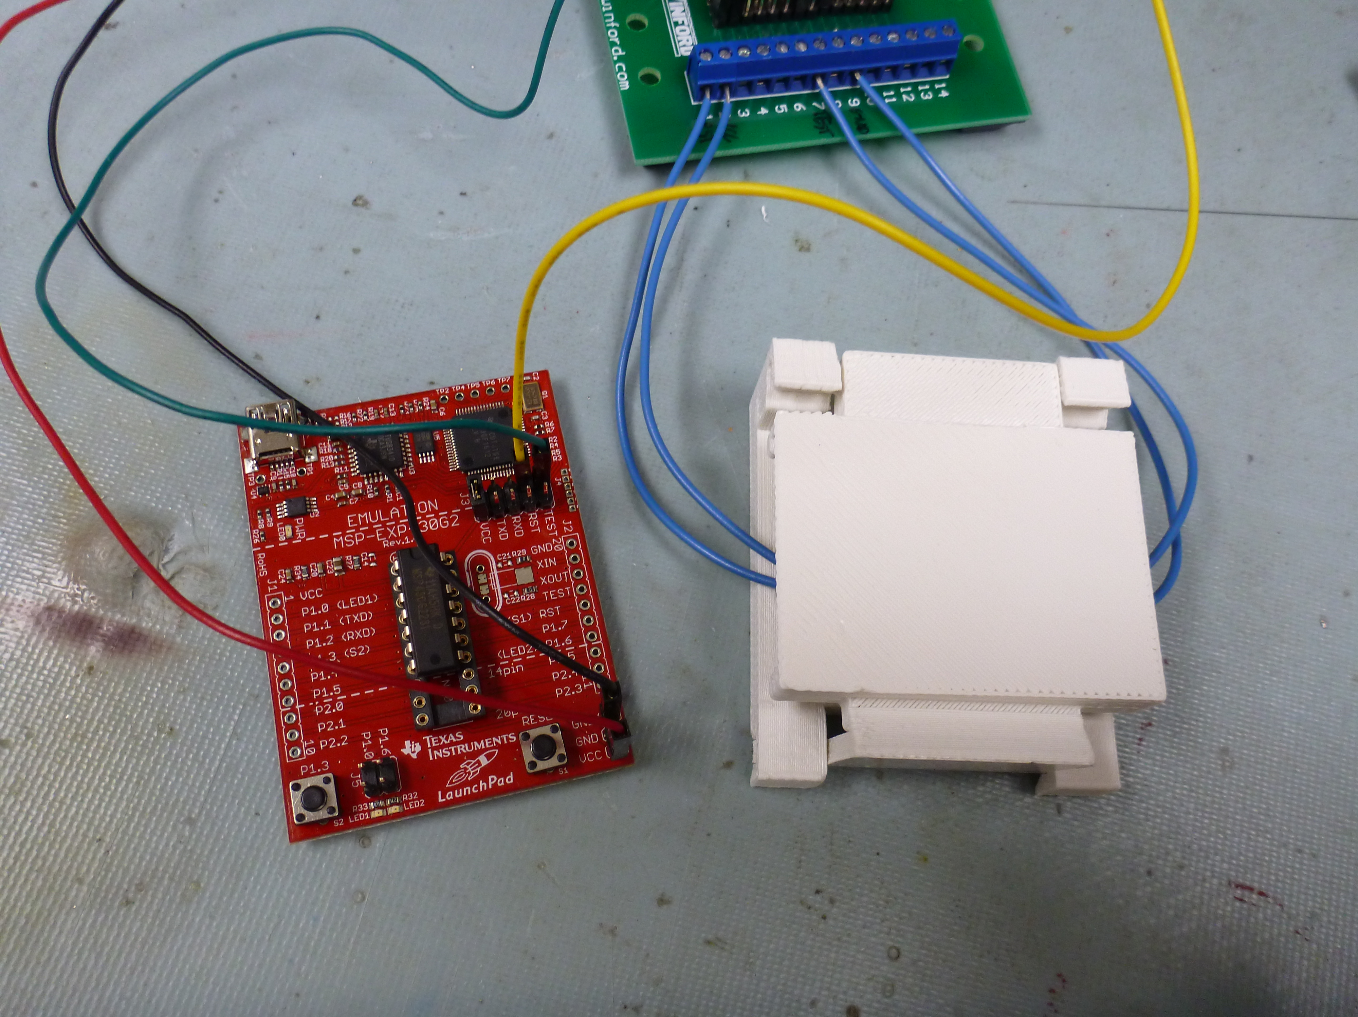

1. Connect TI Launchpad to computer via USB cable
2. Open the SpriteBlink sketch inside Energia
3. Upload the SpriteBlink sketch to the board



1. Verify that LEDs on the board blink

